**Waikato Bays Region Interclub Final**

On Sunday August 24th the final of the Interclubs Teams Competition was held.

There were 2 qualifiers from each of Bay of Plenty and Waikato for each category (Open, Intermediate, Junior).

The qualifiers were:

Junior – Whakatane and Rotorua, and Waikato and Thames

Intermediate – Thames and Hamilton, and Mt Maunganui and Rotorua

Open – Hamilton and Matamata, and Tauranga and Mt Maunganui

With a round robin format each team played the others in 16 board matches.

At the final reckoning the following teams were victorious:

Junior – Whakatane

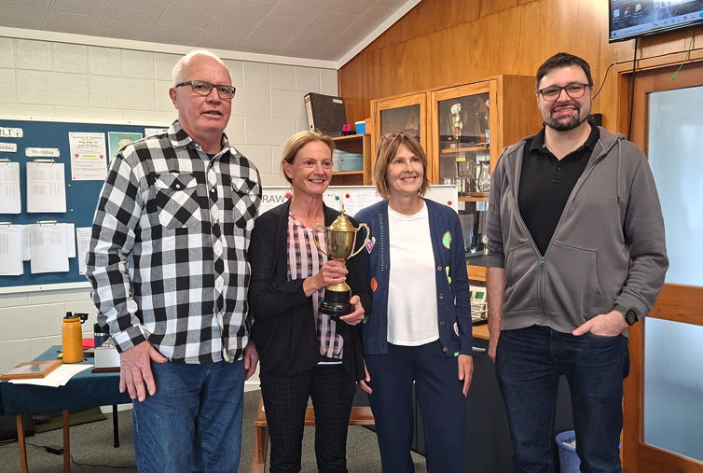

Sue Clark, Claire Barkla, Mike Whalley and Mathia Herzog

Intermediate – Thames

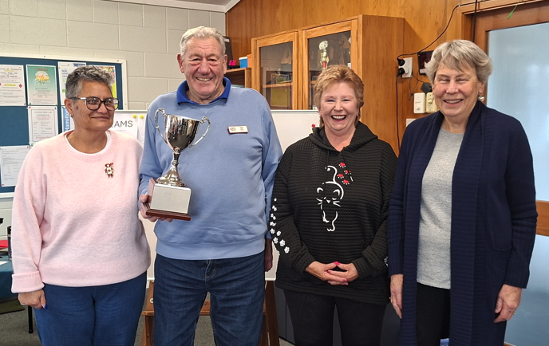

Ted Cliffin, Nita Knight, Sabrina Peters and Josie Mckenzie

Open – Hamilton

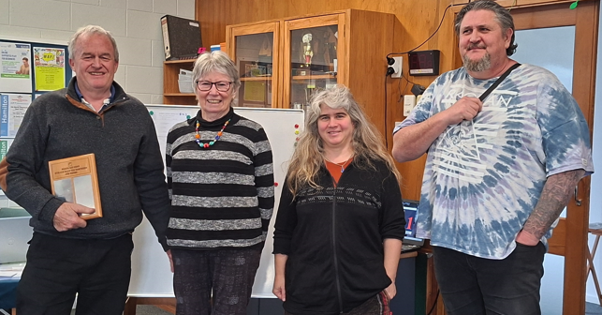

Barry Jones, Jenny Millington, Karen Harris and Michael Curry